NAME: MARTIN R. CASARES COURSE AND SECTION: BSIT-3B
Course: Web Systems Technology
Objective: Students will install, configure, and run Laravel or CodeIgniter on their local machine while demonstrating understanding of MVC structure, routing, and configuration files.
Rules:
1. Student must do it and be able to demonstrate how to setup the environment
2. Official documentation is allowed.
3. Each milestone must be signed off by the instructor.
4. Handwritten logs and reflections required.
5. Students must demonstrate working outputs live for verification.
CodeIgniter
Phase 1 – Environment Setup (Checkpoint 1)
Tasks | Progress Log | Comments/Feedback
Download CodeIgniter. | 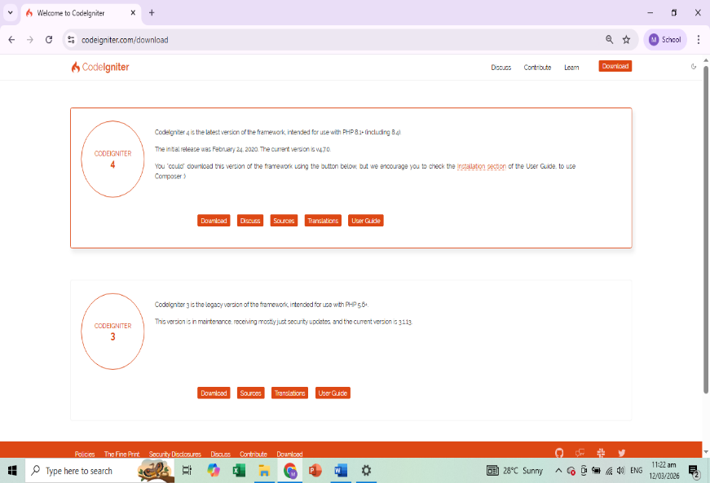 | After opening a browser, I manually search for CodeIgniter4 to Download, I successfully installed and set up the CodeIgniter framework on my local machine. I configured the necessary environment tools such as the web server and ensured that PHP and Composer were properly working.
Extract to htdocs (or local server folder). | 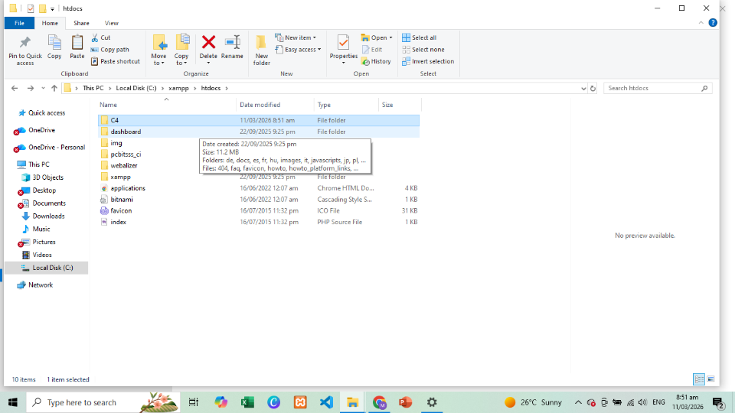 | I extracted the downloaded CodeIgniter files into the htdocs folder of the local server. If I did it correctly proper extraction ensures the system could run the framework correctly.
Open project and display default page | 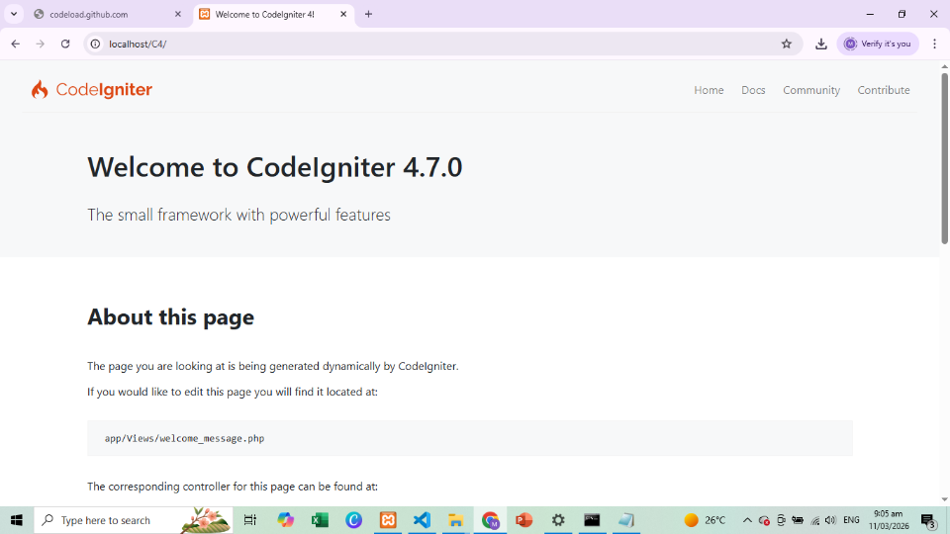 | And then I opened the project in the browser to check if the CodeIgniter default welcome page appears. Seeing the default page confirmed that the framework was installed successfully
Correct folder placement | 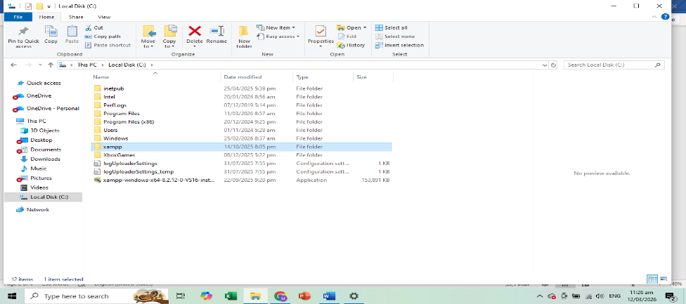 | I checked if the project folder was placed correctly inside the server directory. Proper folder placement is important so the server can locate and run the project without errors. This step helped avoid path or access issues during development.
Working URL access. | 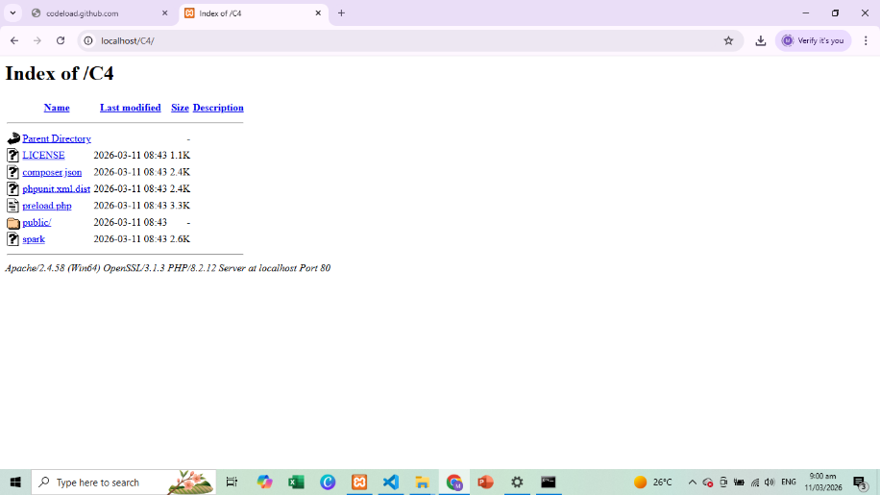 | I tested the project by accessing it through the browser using the correct URL. The successful loading of the page confirmed that the link and server connection were working.

Step-by-step installation summary:

Phase 2 – Environment Configuration (Checkpoint 2)
Tasks | Progress Log | Comments/Feedback
Configure baseURL.
Configure database connection.
Remove index.php from URL using .htaccess
- Explain baseURL.
_
- Explain public folder and writable folder.
_

Phase 3 – Structure Understanding (Checkpoint 3)
Identify and write:
1. Controllers folder
2. Views folder:
3. Models folder:
4. Routing configuration file
5. Purpose of writable folder: _____
Explain auto-routing vs defined routes.

Phase 4 – Mini Functional Output (Checkpoint 4)
Tasks | Progress Log | Comments/Feedback
Create a controller.
Create a view.
Define /profile route.
Pass dynamic data to view (full name, course/year, date).
Verify proper data passing and MVC connection.

- Draw the MVC diagram.
- 3 common errors and solutions.
- How to troubleshoot project load failures.

